LRU Cache in Java
These notes explain your HashMap and doubly linked list solution, including pointer updates, eviction, and time and space complexity. The accompanying LRUCache.java preserves your approach of replacing an accessed node with a new node at the front.

What the cache must do
LRU means least recently used. The cache stores a limited number of key and value pairs. When a new key arrives and the cache is full, it removes the entry that was accessed least recently. A successful get and every put make the affected entry most recently used.
get(key) returns the stored value or −1 if the key is absent. put(key, value) updates an existing key or inserts a new one. An update does not increase the number of entries.

Why two data structures are needed
Map<Integer, Node> finds the exact node for a key in average O(1) time. The doubly linked list records usage order and lets us unlink a known node without searching for its predecessor. A map alone does not maintain the recency order used by this implementation.
Field | Purpose
key | Identifies the map entry to remove during eviction.
val | Stores the cached value returned by get.
prev and next | Link the node to its neighbors.
head and tail | Dummy nodes that simplify insertion and removal.

The ordering rule
head.next is the most recently used real node. tail.prev is the least recently used real node. Dummy nodes are not cache entries and are never stored in the map. Initially head.next = tail and tail.prev = head.
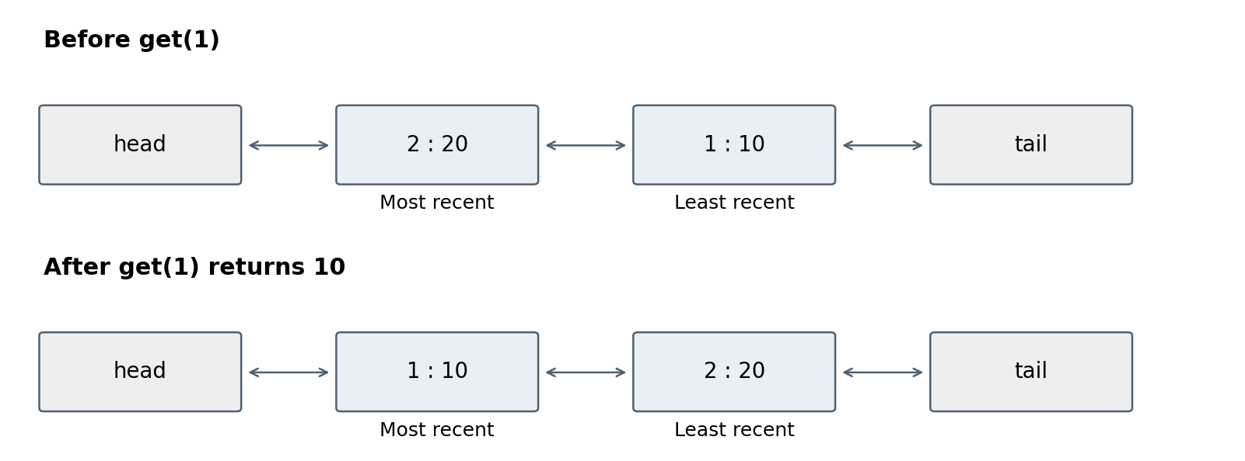

How the pointer helpers work
addNode(key, value) creates a node and inserts it immediately after head. Save the old first node before changing head.next so that the rest of the list remains reachable.
Node temp = head.next;
head.next = newNode;
newNode.prev = head;
newNode.next = temp;
temp.prev = newNode;
The first two assignments connect head and the new node. The next two connect the new node and the old first node. This also works for an empty list because temp is then tail. Return newNode so the caller can store its reference in the map.
deleteNode(key) gets the node from the map and connects its two neighbors directly to each other:
Node presentNode = map.get(key);
Node prevNode = presentNode.prev;
Node nextNode = presentNode.next;
prevNode.next = nextNode;
nextNode.prev = prevNode;
No traversal is needed. The helper only unlinks the node; it does not remove the map entry. Its precondition is that the key exists. The caller must subsequently replace or remove the map reference.

How get updates recency
If the key is missing, return −1 and leave the ordering unchanged. Otherwise, save its value, unlink its old node, create a replacement at the front, replace the map reference, and return the saved value.
int value = map.get(key).val;
deleteNode(key);
Node updatedNode = addNode(key, value);
map.put(key, updatedNode);
return value;
Updating the map is essential: addNode creates a different object. Without map.put, the map would still point to the detached old node. Reusing the existing node is an optional optimization that avoids this allocation; it is not required for correctness.

Why the key is stored twice
The map uses a key to locate a node. During eviction, we start with the node at tail.prev instead. Its key tells us which map entry to remove without scanning the map.

How put handles each case
Existing key: unlink the old node, create a replacement with the new value at the front, and replace the map reference. Check this case before checking capacity, because an update must work even when the cache is full.
New key with room: create a node at the front and store its reference in the map. The cache size increases by one.
New key when full: save tail.prev, unlink that node, remove its map entry, then insert the new key at the front and into the map. The cache size remains equal to capacity.
Node tailPrevNode = tail.prev;
deleteNode(tailPrevNode.key);
map.remove(tailPrevNode.key);
map.put(key, addNode(key, value));
The order matters: deleteNode reads map.get(key), so it must run before map.remove(key). Reversing the order would make presentNode null. Java Map uses remove, not delete.

A complete walkthrough
Capacity is 2. The order below lists keys from most recent to least recent; dummy nodes are omitted.
Operation | Result | Order | Reason
put(1, 10) | — | 1 | Insert key 1.
put(2, 20) | — | 2, 1 | Insert key 2 at the front.
get(1) | 10 | 1, 2 | Key 1 becomes most recent.
put(3, 30) | — | 3, 1 | Evict key 2.
get(2) | −1 | 3, 1 | A miss does not change order.
put(1, 15) | — | 1, 3 | Update key 1; size stays 2.
put(4, 40) | — | 4, 1 | Evict key 3.
get(1) | 15 | 1, 4 | Return the updated value.

Corrections from your earlier versions
Use this.capacity = capacity to initialize the field. Construct real nodes with both key and value. Return a Node from addNode and an int value from get. Update recency on a successful get. Remove an evicted entry from both structures, in the correct order.
The Java file also handles capacity 0 by ignoring put calls, so it never tries to evict a dummy node. Negative capacity is rejected. The list helpers are private because calling them independently would leave the map and list inconsistent.

Time complexity
Operation | Time | Explanation
get | O(1) average | A fixed number of map operations and pointer updates.
put | O(1) average | At most one eviction and one insertion or replacement.
addNode | O(1) | Creates one node and updates four links.
deleteNode | O(1) average | One map lookup and two link updates.
Constructor | O(1) | Creates an empty map and two dummy nodes.
HashMap operations are average constant time, not a strict worst case guarantee. Resizing can make an individual insertion slower; insertion cost is also amortized across operations. The linked list work itself is always constant time because there is no loop or traversal.

Space complexity
Let C be the capacity. The map contains at most C entries, and the list contains at most C real nodes plus two dummy nodes. The map references the same node objects that form the list; it does not hold copies of them. Total live storage is O(C + 1), conventionally written O(C) for positive capacity.
Each get or put uses O(1) additional temporary space. In your implementation, a successful get or update creates a replacement node. Detached nodes become eligible for garbage collection after the map reference is replaced. Over many operations this creates allocation work, but it does not increase the asymptotic live cache size.

Checks to remember
- Every map entry points to exactly one real node in the list.
- Every real list node has a matching map entry.
- Successful reads and all stored writes move the entry to the front.
- Only tail.prev is evicted, and dummy nodes are never evicted.
- An existing key is updated without increasing map.size().

Using the Java file
LRUCache.java includes the imports, Node class, and public LRUCache class. It has no main method because it is designed to be instantiated by a caller or a coding platform.
LRUCache cache = new LRUCache(2);
cache.put(1, 10);
cache.put(2, 20);
System.out.println(cache.get(1)); // 10
cache.put(3, 30);
System.out.println(cache.get(2)); // -1

